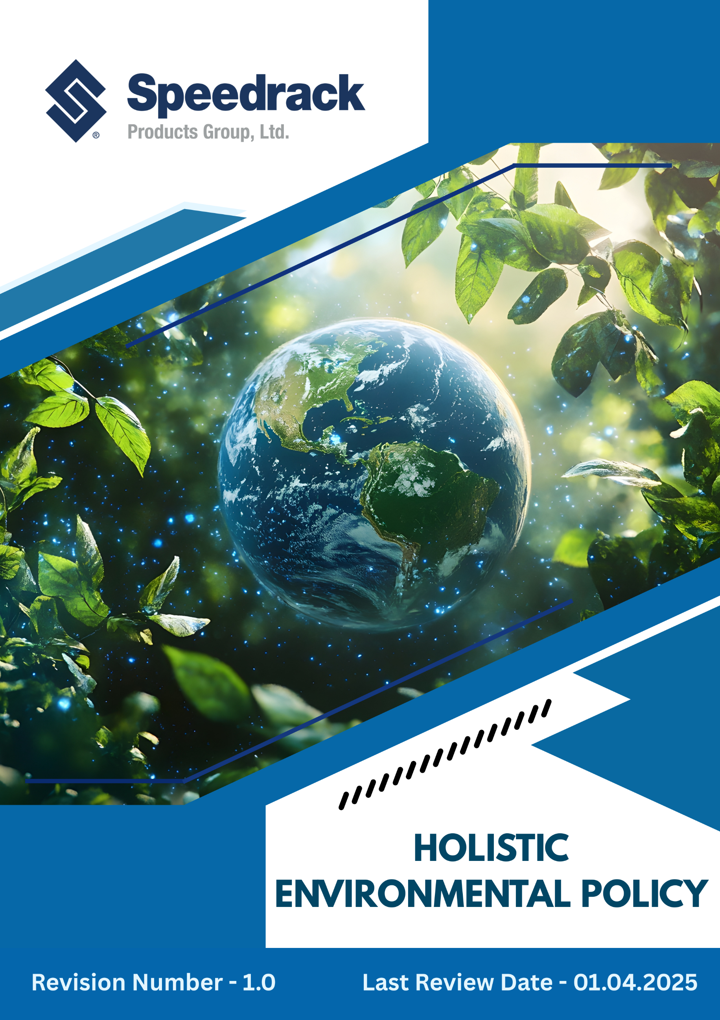
Table of Contents
Introduction 3
Purpose 3
Scope. 3
Our Focus Areas 4
Speedrack’s Approach towards the issues 4
Responsibility of this Policy 8
Reporting 9
Continuous Improvement 9
SDGs Covered by This Policy 9
Annual Review Mechanism 10
Employee Acknowledgement Form 10

Introduction
Speedrack Products Group, Ltd. is committed to conducting all its operations with the highest regard for environmental responsibility and sustainability. As a leading U.S. manufacturer of advanced storage and racking systems, we recognize that our activities—from steel sourcing and fabrication to finishing and distribution—have an impact on the environment. Through this policy, we aim to integrate environmental considerations into every stage of our business decisions. Our goal is to minimize waste, conserve resources, reduce emissions, and continually improve our environmental performance. By promoting responsible manufacturing practices and fostering a culture of sustainability, Speedrack seeks to protect natural ecosystems while supporting long-term value creation for our employees, customers, and communities.

Purpose
- To define Speedrack’s overarching commitment to environmental protection and sustainable manufacturing.
- To ensure that all operations, products, and services are conducted in compliance with applicable environmental laws and regulations.
- To promote responsible use of natural resources, including energy, water, and raw materials.
- To prevent pollution and minimize waste generation through efficient production and recycling practices.
- To reduce greenhouse gas emissions and support the transition to low-carbon manufacturing processes.
- To integrate environmental considerations into product design, procurement, and life-cycle management.
- To engage employees, suppliers, and customers in achieving shared sustainability goals.
- To establish a framework for setting, reviewing, and continually improving environmental objectives and performance.

Scope
This policy applies to all employees, stakeholders, contractors, partners, customers, contract workers, and individuals representing the company at the following sites. It is also applicable to all operational facilities, corporate offices, and any other premises under the company's management.
Sr. No | Unit Name | Address
1 | Manufacturing Site | 42 Cole St, Quincy, MI 49082
2 | Manufacturing Site | 3060 S Industrial Dr NW Walker, MI 49544
3 | Corporate Office | 3060 S Industrial Dr NW Walker, MI 49544

Our Focus Areas
- Energy Efficiency: Optimize energy consumption across all manufacturing and administrative operations through advanced technologies and process improvements.
- Resource Conservation: Promote responsible use of raw materials, water, and other natural resources to minimize environmental impact.
- Waste Management: Implement effective systems for segregation, recycling, and responsible disposal of metal scrap, packaging, and hazardous waste.
- Emissions Control: Reduce air emissions from fabrication, welding, and coating operations by using cleaner technologies and maintaining efficient filtration systems.
- Sustainable Sourcing: Prioritize procurement of eco-friendly materials and collaborate with suppliers who follow ethical and sustainable practices.
- Product Lifecycle Stewardship: Design durable, recyclable racking systems that support circular economy principles.
- Pollution Prevention: Eliminate or reduce potential pollutants through process control, preventive maintenance, and substitution of hazardous substances.
- Awareness & Training: Educate employees and stakeholders on environmental best practices and encourage active participation in sustainability initiatives.

Speedrack’s Approach towards the issues
The following targets have been set in alignment with Speedrack’s 2022 baseline performance data.
- Energy and GHG emission
- Sustain and expand the use of airflow equipment around heat-generating areas to manage ambient temperatures effectively — dispersing heat in summer and recapturing it in winter to lower overall energy demand.
- Continue operating powder-coat ovens at reduced temperatures to minimize energy consumption while maintaining superior coating quality and production efficiency.
- Speedrack will modernize all manufacturing facilities with high-efficiency LED lighting and automated energy control systems to ensure operational excellence and achieve a 15% reduction in total energy consumption by 2030.
- The company will upgrade welding, fabrication, and coating equipment with energy-optimized technologies that support lean manufacturing, aiming to lower overall electricity intensity by 20% by 2030.
- By investing in on-site solar and renewable energy procurement, Speedrack commits to sourcing at least 20% of total electricity from renewable sources by 2030 and cutting Scope 2 emissions by 10% within the same period.
- To minimize fuel-related emissions, we will convert 20% of its internal logistics and forklift fleet to electric models by 2030, resulting in a 6% reduction in Scope 1 emissions.
- We aim to reduce Scope 3 emissions by 10% by 2035, through optimized transport routes, use of recycled steel, and local sourcing.
- In line with global climate goals, Speedrack aims to achieve carbon neutrality across all operations (Scopes 1, 2, and 3) by 2050 through energy efficiency, renewable integration, and certified carbon offset programs.
- Waste Management
- Company-wide recycling initiatives have already reduced landfill waste by over 75%, with a goal to achieve zero waste-to-landfill certification by 2030 through enhanced segregation, reuse, and recovery systems.
- Currently, over 70% of finished product content comes from recycled materials; this will be increased to 85% by 2030 through exploring new sourcing opportunities and procuring higher volumes of recyclable steel, along with optimized recovery of production scrap.
- All coating and cleaning materials are being transitioned to non-toxic and environmentally safe alternatives, targeting the complete elimination of phosphate-based and hazardous chemicals by 2030 to ensure safer operations and minimal environmental risk.
- To lower raw material consumption, the organization will implement precision cutting, real-time production monitoring, and lean manufacturing techniques, aiming for a 15% reduction in total material wastage by 2030.
- We aim to reduce use of single-use plastic packaging by 20% 2030, with a full shift to recyclable or reusable packaging materials that align with circular economy principles.
- All non-recyclable and hazardous waste will be sent to certified disposal vendors, aiming for 100% compliance by 2030 through regular vendor audits.
- Annual employee training on waste handling and chemical safety will cover all staff by 2030, aim to cover 100% of employees in it.
- Water Management
- The organization strives to reduce overall water consumption intensity by 20% by 2030 through the adoption of water-efficient fixtures and proactive leak monitoring across all facilities.
- It aims to implement rainwater harvesting and storage systems at manufacturing sites by 2030, enabling the reuse of at least 15% of total process water for non-potable applications.
- The company is committed to transitioning metal cleaning and coating operations to low-water or waterless treatment technologies by 2030, minimizing dependence on freshwater resources.
- All wastewater generated from production and sanitation processes will be fully treated and reused or safely discharged by 2030, ensuring compliance with environmental standards.
- The organization endeavors to enhance employee engagement through annual water conservation training, targeting 100% staff participation by 2030.
- By 2030, it plans to introduce real-time water monitoring systems across all major facilities to track usage trends and identify opportunities for continuous efficiency improvements.
- Air Pollution Management
- The organization aims to reduce overall air emissions intensity by 25% by 2030 through cleaner production technologies, regular equipment maintenance, and process optimization.
- It strives to upgrade welding, coating, and fabrication systems with advanced filtration and fume extraction units by 2030, ensuring a 40% reduction in particulate emissions from production areas.
- The company is committed to minimizing volatile organic compound (VOC) emissions by adopting low-VOC or water-based paints and coatings, targeting a complete phase-out of high-VOC materials by 2030.
- It endeavors to maintain all stack and process emissions within permissible regulatory limits, supported by continuous monitoring, preventive maintenance, and periodic third-party testing.
- The organization endeavors to improve indoor air quality standards through upgraded ventilation systems and the regular monitoring of workplace air parameters, ensuring compliance with OSHA and EPA standards.
- By 2030, the company commits to using cleaner fuels and optimizing logistics routes, achieving a 10% reduction in transport-related emissions from internal and supplier fleet operations.
- Product End-of-Life & Circularity
- Aim to conduct Product Life-Cycle Assessments (PLCA) for at least four major product lines by 2030 to evaluate and reduce environmental impacts throughout manufacturing, use, and end-of-life stages.
- Commit to design all new racking systems for 30% recyclability by 2030, emphasizing modular structures, ease of disassembly, and the use of recyclable steel and coatings.
- Plan to refurbish or reuse at least 5% of returned or decommissioned racks and components by 2030, extending product lifespan and reducing raw material demand.
- Aim to eliminate hazardous coatings and materials that contribute to microplastic or toxic waste generation by 2030, ensuring all products remain safe for recycling and disposal.
- Endeavor to publish recyclability and safe disposal guidelines on all of our finished products by 2030 and provide these resources to customers during installation, promoting responsible handling at the end-of-life stage.
- Aim to educate customer representatives at the time of installation on product safety, handling, and disposal practices to ensure proper lifecycle management and workplace safety.
- Commit to achieving at least 85% recycled material content in new racks by 2030 and to conducting regular safety inspections, re-labelling, and replacement of damaged components in line with RMI and rack safety organization guidelines.
- Logistics
- All products are proudly 100% American-made, using high-quality steel sourced from domestic suppliers, supporting local industry and reducing transportation-related environmental impacts.
- Aim to optimize transport routes and delivery schedules to reduce fuel consumption and associated greenhouse gas emissions across inbound and outbound logistics.
- Strive to transition at least 20% of the internal and supplier fleet to electric or hybrid vehicles by 2030, reducing Scope 1 and Scope 3 transport-related emissions.
- Aim to digitize 20% of logistics and warehouse operations by 2030, reducing paper usage, improving tracking efficiency, and minimizing operational waste.

Responsibility of this Policy
- President
- Provide overall leadership and commitment to the Holistic Environmental Policy.
- Approve policy updates, sustainability targets, and resource allocation.
- Vice President – Operations / Manufacturing
- Implement energy, water, and waste reduction initiatives across all plants.
- Monitor performance metrics and report progress to senior management.
- Oversee compliance with environmental regulations and operational standards.
- Chief Environmental Officer
- Review the policy annually.
- Lead the development and continuous improvement of environmental programs.
- Conduct audits, assessments, and reporting in line with regulatory requirements.
- Track progress toward targets and recommend corrective actions.
- Provide guidance and support to all departments on environmental best practices.
- Director of Supply Chain & Logistics
- Implement sustainable logistics practices, including route optimization, fleet electrification, and packaging reduction.
- Track and report logistics-related emissions and improvements.
- Plant Managers
- Execute environmental programs at the facility level.
- Ensure compliance with operational procedures, emissions standards, and waste management practices.
- Report environmental performance, incidents, and improvement opportunities to corporate management.

- Employees
- Follow environmental procedures and policies in daily operations.
- Participate in training programs and contribute ideas for sustainability improvements.

Reporting
- Environmental performance will be tracked and reviewed annually through internal sustainability scorecards and site-level performance reports.
- The EHS Department will compile an annual summary of key indicators such as energy use, emissions, waste, and water performance for management review.
- Findings, progress, and improvement actions will be reported to senior leadership during management review meetings and included in the company’s sustainability disclosures.
- Significant updates, achievements, and targets will be communicated to employees, customers, and stakeholders through internal newsletters and the annual sustainability report.

Continuous Improvement
The organization is committed to continuous improvement in its environmental performance by integrating sustainability principles into all operations. Regular reviews, employee engagement, and adoption of cleaner technologies will drive efficiency, reduce emissions, and minimize waste. Feedback from audits and performance assessments will guide ongoing enhancements to environmental initiatives.

SDGs Covered by This Policy
This Environmental Policy supports the following United Nations Sustainable Development Goals (SDGs):
 |  | 

Review Mechanism
The Chief Environmental Officer (CEO) will conduct an annual review or as needed of this policy to evaluate progress toward environmental objectives, ensure regulatory compliance, and assess emerging sustainability risks. Based on performance results, the policy may be updated to reflect new goals, technologies, or best practices, ensuring its continued relevance and effectiveness.
Effective Date: 01.12.2024
Last Review Date: 01.04.2025 Rev. No. 1.0
Next Review Date: 01.04.2026

Employee Acknowledgement Form
I acknowledge that I have received, read, and understood the company’s Holistic Environmental Policy.
I am aware of my responsibilities under this policy and commit to supporting the organization’s environmental goals through responsible practices, resource conservation, and adherence to all environmental procedures and standards.
I understand that compliance with this policy is a condition of employment, and failure to follow its requirements may result in corrective action as outlined in company policies.
By signing below, I confirm my understanding and agreement to comply with the Environmental Policy.

Employee Name: ___________________________________
Department: ________________________________________
Designation: ________________________________________
Signature: ___________________________________________
Date: ______________________________________________

